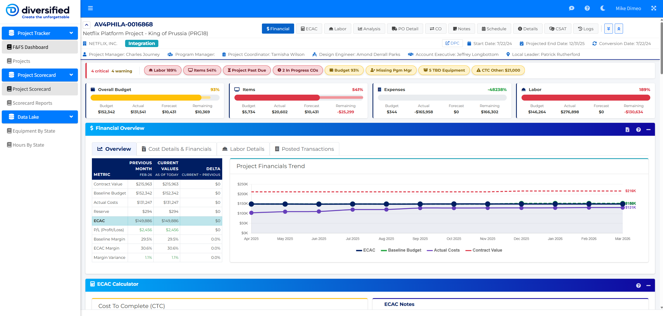

12. Suggested Domain Model
Examples of entities to define early:
- Dispatch
- Visit
- Case
- Site
- Client
- Technician
- Supervisor
- Scope
- ScopeVersion
- Project
- BOMLine
- ValidationResult
- AutomationEvent
- AIJob
- Comment
- Attachment
These should be normalized in TypeScript interfaces so the app remains stable even if source files change.

13. API Direction
Design internal APIs around business actions, not file structure.
Example endpoints
- GET /api/dispatch
- GET /api/dispatch/:id
- GET /api/cases/:caseNumber
- POST /api/scopes/generate
- POST /api/scopes/rewrite
- POST /api/scopes/validate
- POST /api/scopes/compare-to-bom
- POST /api/automation/trigger
- GET /api/weather
- GET /api/traffic
- POST /api/uploads/excel
API design principles
- normalize responses
- log important actions
- expose confidence and warnings clearly
- return reviewable output, not black-box decisions
- keep AI prompts and orchestration modular

14. AI Guardrails
AI can accelerate workflow, but the application should be designed with review and traceability in mind.
Principles
- Human review remains in the loop for important scope decisions
- AI suggestions should be labeled clearly
- Inputs used to generate or validate a scope should be traceable
- Confidence should never be presented as certainty
- Scope-vs-BOM mismatch results should be reviewable and explainable
- Prompt templates should be versioned where practical
High-value guardrail ideas
- Require approval for “Likely Out of Scope” determinations before finalizing customer-facing language
- Save AI source context used for major generated outputs
- Distinguish between generated draft language and approved final language
- Log trigger source for automated AI runs

15. Environment Variables
Initial examples:
# App
NODE_ENV=development
PORT=3000
# Data
DATA_SOURCE=excel
EXCEL_DISPATCH_FILE=./data/current/dispatch.xlsx
EXCEL_BOM_FILE=./data/current/bom.xlsx
# Auth
AUTH_MODE=local
# AI
OPENAI_API_KEY=your_key_here
AI_MODEL=to_be_determined
# External intelligence
WEATHER_API_KEY=your_key_here
TRAFFIC_API_KEY=your_key_here
# App behavior
APP_TIMEZONE=America/New_York
Add, remove, or rename these as architecture decisions are finalized.

16. Local Development Goals
Initial local workflow should be simple:
- Clone repo
- Install dependencies
- Add .env.local
- Provide sample Excel files
- Run development server
- Begin building feature slices incrementally
Example starter flow:
npm install
npm run dev

17. Railway Deployment Goals
The initial Railway deployment should support:
- fast iteration
- simple environment variable management
- easy prototype demo access
- support for temporary file-backed workflows
- clean transition to future managed services
Early deployment notes
- Keep sensitive production data out of the repo
- Use environment variables for API keys and settings
- If writable files are needed, handle that intentionally
- Prefer sample or sanitized workbooks in development/demo environments

18. Recommended Build Sequence
Foundation
- Create Next.js project with TypeScript and styling setup
- Define core layout and navigation
- Build data service abstraction
- Add Excel ingestion/parsing layer
- Create initial dashboard + dispatch board
Scope workflow
- Build scope builder shell
- Add structured scope sections and editor
- Add save/load/version pattern
- Add AI draft generation endpoints
- Add scope review experience
Validation workflow
- Add BOM ingestion model
- Add scope-to-BOM comparison service
- Add validation UI with confidence and reviewer notes
Intelligence workflow
- Add weather integration
- Add traffic/ETA integration
- Add dispatch risk indicators
Automation workflow
- Add trigger/event model
- Add automated AI actions for selected workflow events
- Add action logging and audit visibility
Enterprise readiness
- Prepare auth abstraction for future SSO
- Refactor data connectors toward enterprise APIs
- Document migration path to Azure/tenant-hosted deployment

19. Definition of Success
This application is successful when it:
- materially improves dispatch visibility
- reduces time required to create scopes
- improves scope consistency and completeness
- helps identify likely out-of-scope asks earlier
- provides better operational awareness around staffing, travel, and risk
- supports a smooth migration path from prototype to enterprise platform

20. Relationship to the Current Python/Dash App
This project replaces the architecture of the existing dashboard while preserving its business purpose.
The current Python-based project focuses on:
- dashboarding
- dispatch visibility
- scope generation
- Excel-backed workflows
The new project should preserve those core operational outcomes while dramatically improving:
- UI/UX
- modularity
- maintainability
- extensibility
- AI integration
- automation support
- enterprise readiness
The existing README and app served as a strong operational baseline for what the tool needs to do. This new app uses that same mission as its foundation while redesigning the implementation around a modern full-stack application model. Source inspiration: fileciteturn0file0

21. Immediate Next Deliverables
Recommended first project artifacts:
- README.md
- initial repository scaffold
- architecture notes
- sample domain types
- data mapping notes for existing Excel sources
- first-pass wireframe / route map
- AI prompt strategy notes
- event/trigger model draft

22. Notes for Future Iteration
As implementation begins, this README should evolve to include:
- actual package choices
- setup instructions
- exact environment variables
- authentication approach
- selected AI provider/model details
- actual data contracts
- deployment specifics
- screenshots and workflow examples
This document should be treated as the product and architecture starting point, not the final specification.
"""
path = Path("/mnt/data/README_new_dispatch_scope_portal.md")
path.write_text(readme, encoding="utf-8")
print(f"Saved to {path}")

